***Project Guidelines***

Store each word in a text file.

Randomly select a word from that file

Store each letter in a 1D array using a for loop.

Switch to the function where the user enters each letter.

One array for the letters and one more array for the words.

After a letter is guessed correctly, a blank is replaced by the letter and the whole word is printed again.

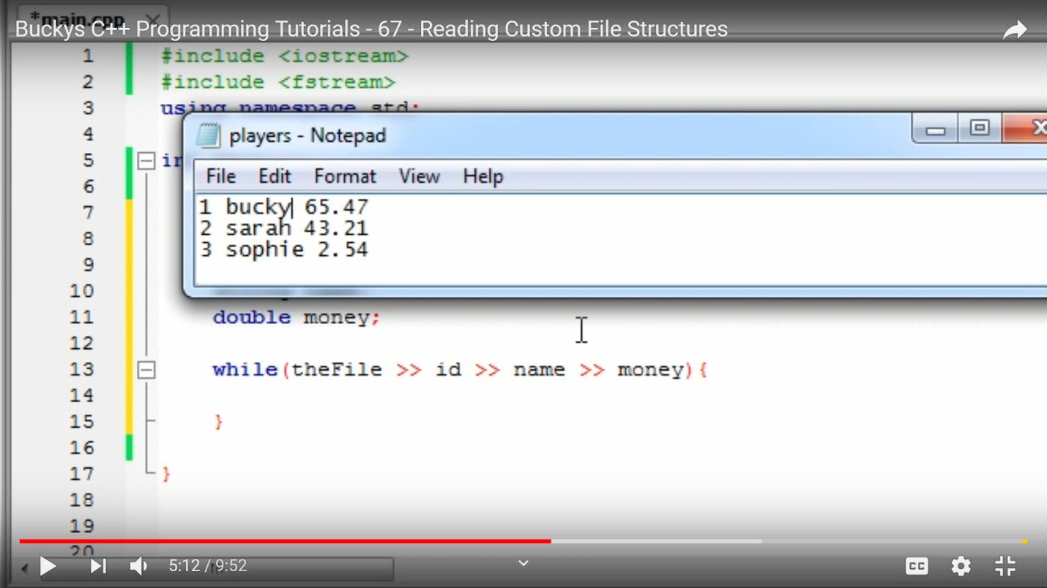

**ERRORS:**

Code does not replace the letter if it is found in two positions in the word.

Problem with rock bands

Congratulations message prints even if the word is not guessed.

Same word appears for car manufacturers.